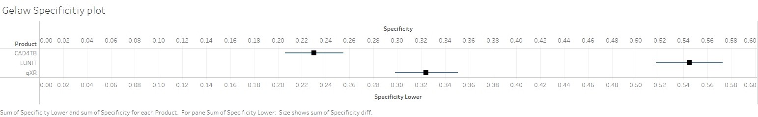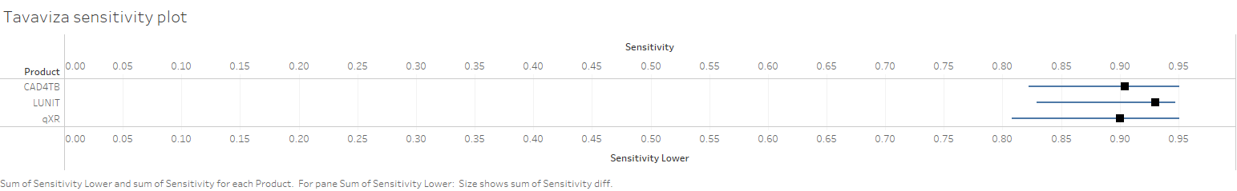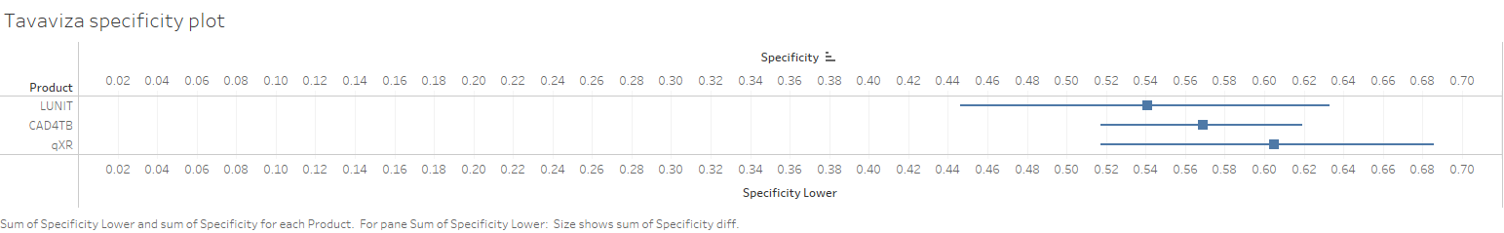

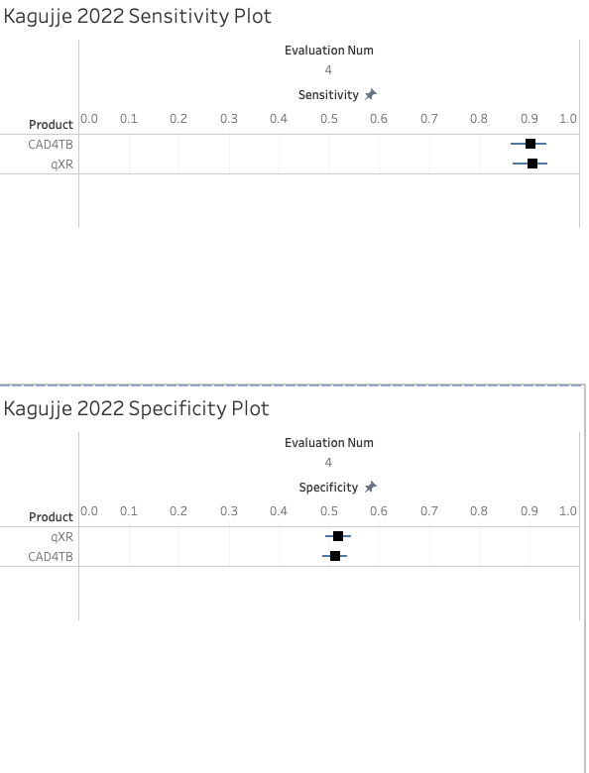

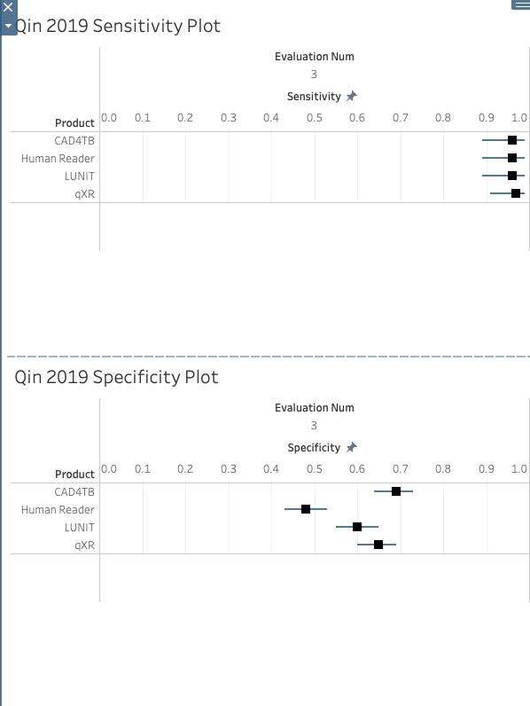

Zhi Zhen Qin 2021 (Zichen Li)

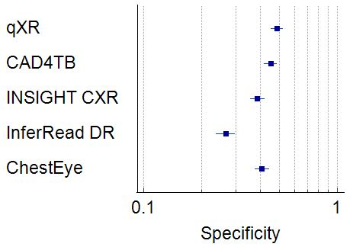

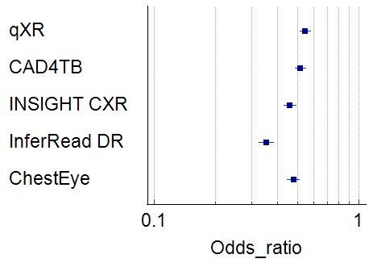

Andrew J (Zichen Li)

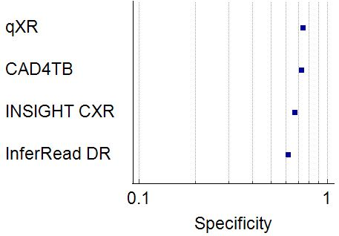

**Qin, 2020**

**Sensitivity with 70% specificity**

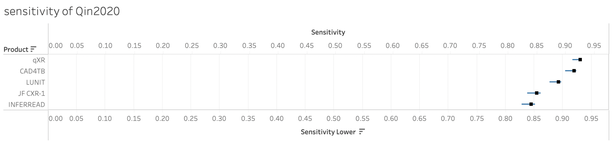

**Specificity with 90% sensitivity**

